Compiling

As we know for comping a c file , in terminal :

$make file-name

But as we know these method isn’t the right , but the right method is to install a compiler then use it ‘s code like : clang and gcc .

And to be honest the code become more long .

$ ./file-name

**$ clang -o file-name file-name.c -lLibary**

**$ . / file-name**



This file name mean the name of the file that computer will write (writed by machine code )

Here you have to declare the libaries that you use them if you use other libary that stdio.h -l …

Compiling steps

The compiling cross , four steps :

1. Proprocessing
2. Compiling
3. Assembiling
4. 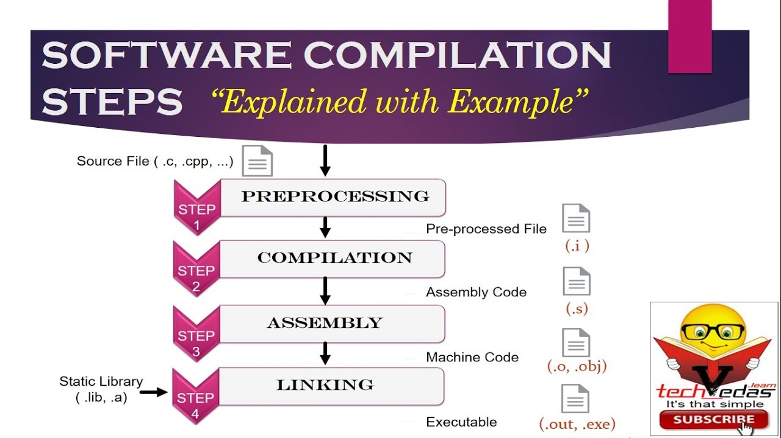Linking

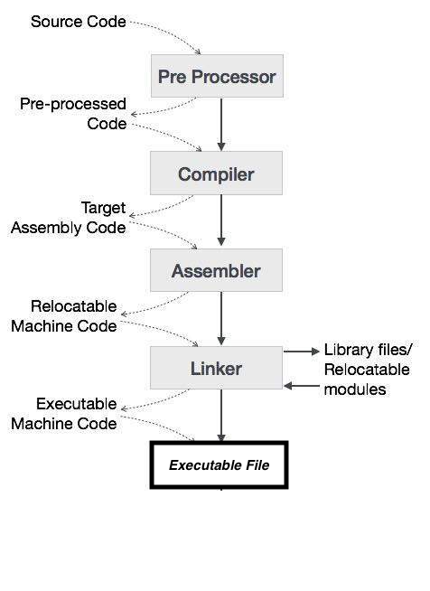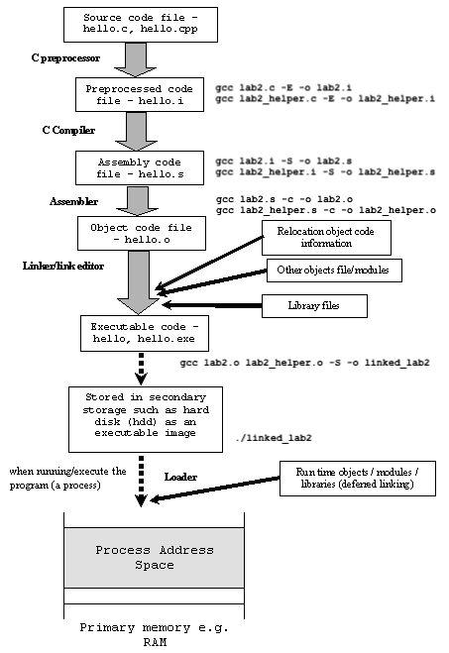

1. Preprocessing : in the code the first thing that we find is include libaries , the the libary contain many command you called it because you use one or many command in it , so proprossing enter this libary and bring the command that you use it in you program

2 . Compiling : in this step we converst c file to assembly code (by assembly language it looks like machine code , and this is why it’s a very fast language )

3.Assembling : Here we convert assembly code to machine code (binary)

4.Linking : when we arrive in this step , we shoud has our code and libaries, in this step the linker make for us a link between libaries and our code and give us the excutable file (binary) with extesion .exe (in windows) or .out(in linux)

**Bug and Debug**

Bug 🡺 is an errror or fault in a computer program or sytem that causes producing an incoreect or unexpected resuld

Debug 🡺 Finding a soulution to the bug (bug =حشرة )

The story of expression « bag »

In 1947 , there was a scientist named ‘grece hover’ she was working on a big project , but there was a problem in that project , and when she discover the problem it express about it ‘bug’

There is two types of fault or bugs

**Syntax Bug :** problem in syntax 🡺 you forget to write somthing in the code or you write somthig wrong

HOW TO DEBUG « SYNTAX BUG «

Cs50 grants to its students a syntax debuger name ‘help50’

As we know we descover that we have a syntax bug when we arrive at compiling step , so here we get error , so for use ‘help50’

At the terminal 🡺 write : $help50 and compile the file normaly

Ex : **$ help50 gcc -o test test.c -lcs50**

Or

Ex : **$ make test**

**Logical Bug :** here you program works but it doesn’t give you the correct result that you want

HOW TO DEBUG « LOGICAL BUG «

Here also cs50 grants its student a debuger name ‘debug50’

This debbuger helps you to compile or move you program in slowmotion mode , and this will help you to find you bug , and to find wich line the program cross the false road , so for start debbuging you must first specify a breakpoint , to tell the computer in which place you will start debbuging, then in the terminal 🡺 write : $debug50 ./file-name

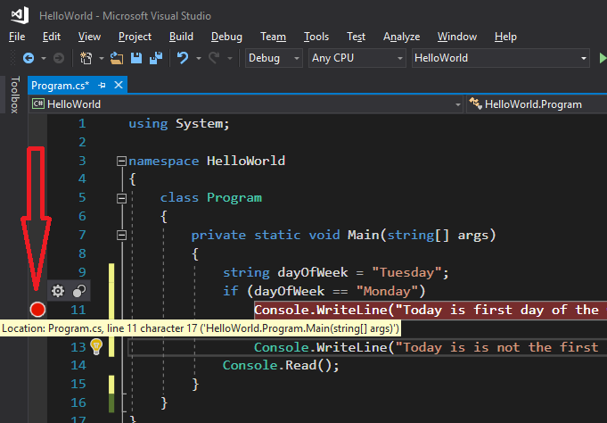

**By this tool we can control our program and move it one step**

**Forward , and this is the breakpoint**







Note : in the syntax bug , we start debuging before compiling , sure because if we have a syntax bug we can’t compile our program

And in logical bug we start debuging after compiling because if we have this time of bug we can compile our program